**Financial & Technical Analysis of SPGI**

**Course:** DAB401 - FINANCIAL ANALYTICS

**Instructor:** Prof. Pratik Bedi

**Team Member:**

* Nitin
* Alisha Mahajan
* Gaurav Negi
* Harshita Sanjay Dhiman
* Pallavi Rajendran

Table of content

Introduction 3

History 4

Present-Day Activities 6

Ratio Analysis 7

Macroeconomic Environment 10

CAMP 11

WACC 12

Stock price for a year 13

SMA & EMA 14

Monte Carlo Simulation 16

FB PROPHET 17

Summary 18

**Introduction**

In order to assist with future investment decisions, a comprehensive financial and technical analysis of SPGI is the goal of this study. To deliver meaningful insights, we aim to present a thorough analysis of the company's financial standing, position in the market, and stock performance.

In the first part of our assignment, we started by thoroughly investigating the firm on many platforms and digging into its past. This required us to fully immerse ourselves in the company's history and analyze its turning points, turning points, and major events as they occurred. Furthermore, we performed comprehensive ratio computations and examined financial indicators including profitability, liquidity, and efficiency to have a better understanding of the business's operations and financial standing. In addition, we evaluated the Weighted Average Cost of Capital (WACC), a critical indicator for figuring out the company's cost of capital that helped us comprehend its financial structure and investment appeal. By taking a thorough approach, we made sure that our project had a solid basis and that our future assessments were based on a solid grasp of the dynamics of the organization both historically and currently.

Making use of a wide range of analytical techniques has been essential to our decision-making process. We have utilized a diverse range of techniques, including methods like Bollinger Bands, Facebook Prophet, Simple Moving Average (SMA), Exponential Moving Average (EMA), and Monte Carlo simulations. An in-depth understanding of our facts and a blend of well-informed conclusions are made easier by the distinct insights and viewpoints that each of these approaches gives. We have been able to negotiate complexity, identify trends, and extract useful insights by using this multifaceted method, which has finally helped us arrive at our conclusions with confidence and clarity.

**History**

The rich history of Standard & Poor's Global Inc. (SPGI) dates back to the late 1800s. Henry Varnum Poor established the Financial Bureau of the United States in 1860, which is where the corporation got its start. This bureau was set up to give investors financial research and information. After changing its name to Standard Statistics Bureau in 1906, the business started offering financial ratings and analysis to railroad firms.

Meanwhile, Luther Lee Blake's Poor's Publishing Company and the Standard Statistics Bureau combined to become the Standard & Poor's Corporation in 1916. By uniting two well-known sources of financial information, the company's position in the market was strengthened.

In the decades that followed, Standard & Poor's grew beyond railroad firms to offer credit ratings and research for a variety of financial products and sectors. It debuted the S&P 500 index in 1941 as a benchmark index of the 500 biggest US publicly listed firms. Since then, it has grown to be one of the most watched stock market indexes globally.

Following the acquisition of Standard & Poor's Corporation by the McGraw-Hill Publishing Company in 1966, McGraw-Hill Financial was established. With the increased reach and resources from this acquisition, Standard & Poor's was able to further develop its services internationally.

The name McGraw-Hill Financial was changed to S&P Global Inc. in 2011 to better represent Standard & Poor's prominent position in the company's financial services offering.

As a top supplier of financial data, research, and ratings, S&P Global Inc. now serves customers in more than a hundred countries and areas. Its services—which include indexes, credit ratings, market information, and data analytics—make it a vital tool for companies, governments, and investors navigating the world's financial markets.

**Present-day activities**

1. **Credit Ratings:** Offering research, analysis, and insights on bonds and securities globally.
2. **Market intelligence:** it is the provision of data, analytics, and research services to firms and financial institutions in a range of industries.
3. **indexes:** constructing and overseeing stock market indexes, such as the Dow Jones Industrial Average and S&P 500.
4. **Platts:** Information, pricing, and analytics for the commodities, metals, energy, and petrochemicals markets.
5. P**roviding risk management solutions**: it is , such as regulatory intelligence and credit risk assessment.
6. Data and Analytics: Providing specialized research services, analytics tools, and exclusive data sets.
7. **ESG Solutions**: Offering ratings, analytics, and ESG data to assist businesses and investors in incorporating ESG considerations.
8. **Market research**: Providing comprehensive studies and analyses in areas such as technology, healthcare, and banking.

**Ratio Analysis**

**Current Ratio:** 0.84

The current ratio evaluates how well the business can use its current assets to pay down short-term debt. A current ratio of 1.5 to 2 is good as it shows that the business has enough current assets to comfortably pay its short-term debts. The current ratio of 0.84 for S&P Global indicates a liquidity problem, which might make it difficult to satisfy short-term financial commitments like debt repayment or operational expenditure payments.

**Quick Ratio:** 0.84

Inventory is not included in the quick ratio, which is a stricter gauge of liquidity than current assets. As with the current ratio, a quick ratio under 1 suggests that there could be a liquidity issue. Concerns about S&P Global's capacity to meet short-term obligations using its most liquid assets, such as cash and accounts receivable, are reinforced by the company's quick ratio of 0.84, particularly in circumstances when inventory cannot be swiftly turned into cash.

**Debt-to-Equity Ratio:** 0.33

The debt-to-equity ratio indicates how much a firm relies on debt financing as opposed to equity financing by comparing its total debt to the equity held by its shareholders. A ratio smaller than one indicates that equity financing, which is typically seen as less hazardous, is the company's primary source of funding. With a debt-to-equity ratio of 0.33, S&P Global has a cautious capital structure that relies less on debt, which lowers the company's financial risk and future interest costs.

**Inventory Turnover Ratio**: 0.00

The inventory turnover ratio calculates the frequency with which a business sells and replaces its stock over a certain time frame to determine how well it maintains its inventory. A ratio of 0 denotes either a very low turnover of inventory or no inventory at all. Given its service-oriented business model and effective inventory control procedures, S&P Global may not maintain a substantial amount of inventory. It is important to take into account how this may affect revenue generation and operational efficiency, even though it may indicate cheaper storage costs and a decreased risk of inventory obsolescence.

**Gross Profit Margin:** 66.86%

The percentage of income that is more than the cost of products sold is reflected in the gross profit margin, which shows how effectively things are produced or services are provided. With a gross profit margin of 66.86%, S&P Global has great operational efficiency and good cost management, outperforming the S&P 500 average of 10.7%. A high gross profit margin indicates that S&P Global is making a significant profit from its main business operations and successfully managing manufacturing costs.\

**Return on Sales Ratio:** 32.17%

The ability of the business to produce a profit from sales revenue is gauged by the return on sales ratio. When compared to other financial services companies, S&P Global's return on sales ratio of 32.17% stands out favourably and shows strong profitability from every dollar of sales. A greater return on sales ratio indicates good management and operational performance at S&P Global and indicates that the company is effective in managing expenses and optimizing profitability in relation to its revenue.

**Return on Total Assets:** 4.77%

The efficiency with which the business generates profit from its complete asset base is assessed by the return on total assets. S&P Global has a return on total assets of 4.77%, which is higher than the banking sector, which usually has a return of less than 1%. Due to its ability to deliver a greater return in relation to its overall asset investment, S&P Global is demonstrating efficient asset usage and excellent management techniques. A greater return on total assets indicates that S&P Global is using its resources to produce profits in an efficient manner, increasing financial performance and shareholder value.

**Return on Equity Ratio**: 8.46%

Profitability of the business in relation to shareholders' equity is gauged by the return on equity ratio. S&P Global's return on equity of 8.46% shows that, although maybe not outperforming certain rivals, it makes a profit with every dollar of shareholders' equity. S&P Global is providing a positive return for its shareholders if its return on equity is higher than the industry average, but in order to evaluate the company's performance in comparison to rivals, it is crucial to take into account its peers and industry.

**Earnings per Share (EPS):** $8.27

The amount of profit allotted to each outstanding share of common stock is expressed as earnings per share, or EPS, for a certain corporation. Strong profitability and maybe appealing investment opportunities are indicated by S&P Global's EPS of $8.27, which is higher than the banking industry's average of $3.15. A greater EPS might be attractive to investors looking for profitable investment options since it indicates that S&P Global is making significant earnings in relation to its outstanding shares.

**Price/Earnings Ratio (PE):** 53.15

By comparing a company's stock price to its profits per share, the price-to-earnings ratio shows how much investors are prepared to pay for every dollar of earnings. The finance industry's PE ratio of 34.63 is less than that of S&P Global, at 53.15, indicating lower growth forecasts and maybe more investor optimism. A greater PE ratio might be a sign that investors believe S&P Global will see rapid profits growth in the future, which would raise the company's stock price. When assessing the PE ratio, it is important to take into account additional aspects such as market circumstances, industry trends, and business performance.

**Dividend Payout Ratio**: 0.49

The percentage of earnings distributed to shareholders as dividends is measured by the dividend payout ratio. With a dividend payout ratio of 0.49, S&P Global shows that it pays out a respectable dividend to shareholders while holding onto a sizable amount of its profits for corporate reinvestment or other uses. A lower dividend payment ratio indicates that S&P Global is putting more of its profits back into the company for development and expansion, which might eventually result in better shareholder value. To please both income- and growth-oriented investors, it is crucial to find a balance between dividend payments and reinvestment.

**Retention Ratio:** 0.51

The percentage of a corporation's earnings that are kept and reinvested in the company rather than paid out as dividends to shareholders is measured by the retention ratio, sometimes referred to as the plowback ratio. With a retention ratio of 0.51, S&P Global is spending almost 51% of its earnings back into the business to fuel growth and development. Reinvestment to support future growth appears to be S&P Global's top priority, as opposed to paying dividends to shareholders, which might eventually result in improved profitability, market share, and shareholder value. This is shown by a higher retention ratio.

**Macroeconomic environment**

S&P Global has historically pursued a combination of organic growth, strategic partnerships, and selective acquisitions to expand its business and maintain its position as a global leader in financial information and analytics.

**Organic Growth:**

•S&P Global consistently invests in developing new products and services

internally to meet the evolving needs of its clients. This approach allows the

company to innovate and enhance its offerings while leveraging its existing

resources and expertise.

**Strategic Partnerships:**

•S&P Global has formed strategic partnerships and joint ventures to

complement its capabilities and expand its reach in key markets.

•Collaborations with other industry players or technology firms enable S&P

Global to leverage synergies, access new markets, and offer integrated

solutions to customers.

•These partnerships enhance S&P Global's competitiveness and help drive

growth by combining complementary expertise and resources.

**Selective Acquisitions:**

•While S&P Global has engaged in acquisitions to strengthen its business, the

company tends to be selective and focused on strategic targets that

complement its existing offerings and enhance its competitive position.

•Acquisitions allow S&P Global to accelerate growth, enter new markets, and

acquire specialized capabilities or technologies. Notable examples include

the acquisitions of SNL Financial in 2015 and IHS Markit in 2020.

•S&P Global evaluates potential acquisitions based on their strategic fit,

financial viability, and potential for value creation, considering market

conditions and regulatory considerations.

**CAMP**

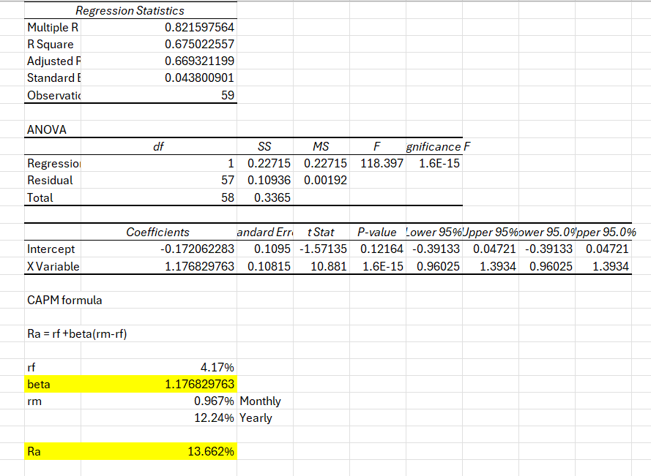

According to the CAPM study, the asset of the firm is anticipated to yield a return of around 13.662%, taking into account its relative risk to the market and the current state of the market. When evaluating the attractiveness of the company's investment opportunity in relation to competing investments with comparable risk profiles, investors and analysts can use this figure as a reference.

**WACC**

|  |  |
| --- | --- |
|  |  |
|  |  |
| **Input Data** |  |
|  |  |
| **Cost of Debt** | **5.05%** |
| **Cost of equity** | **8.42%** |
| **Output** |  |
|  |  |
| **Weight of Debt** | **8%** |
| **Weight of Equity** | **92%** |
| **TOTAL** | **100%** |
|  |  |
| **WACC** | **8.15%** |

All things considered, the computed WACC of 8.15% indicates the cost of capital for the company and offers insightful information for capital budgeting, investment decision-making, and business valuation procedures. It aids in determining if the business can provide returns greater than its financing costs, which will eventually affect its profitability and capacity to create value.

**Stock price for a year**

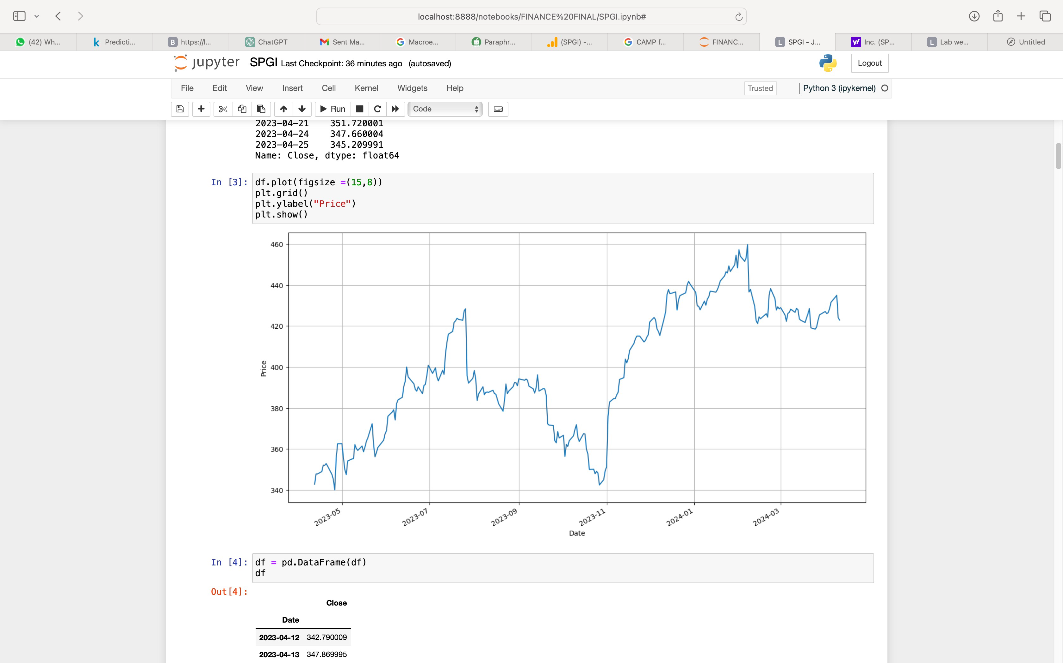

November 2023 saw an abrupt rise in the roller coasters height. Why? That's because, at roughly that same period, stock buyers—as we like to call those who purchase stocks—began to feel quite positive about the stock market. They gained self-assurance and optimism about their ability to profit from stock purchases. Stock prices rose sharply because of this abrupt change in attitude from being cautious or uncertain to feeling optimistic. It seems like everyone decided suddenly that they wanted to purchase stocks in the hopes of becoming extremely wealthy. As a result, this shift in mood will drive the stock prices to rise significantly around November 2023, as you can see from the chart.

**SMA & EMA**

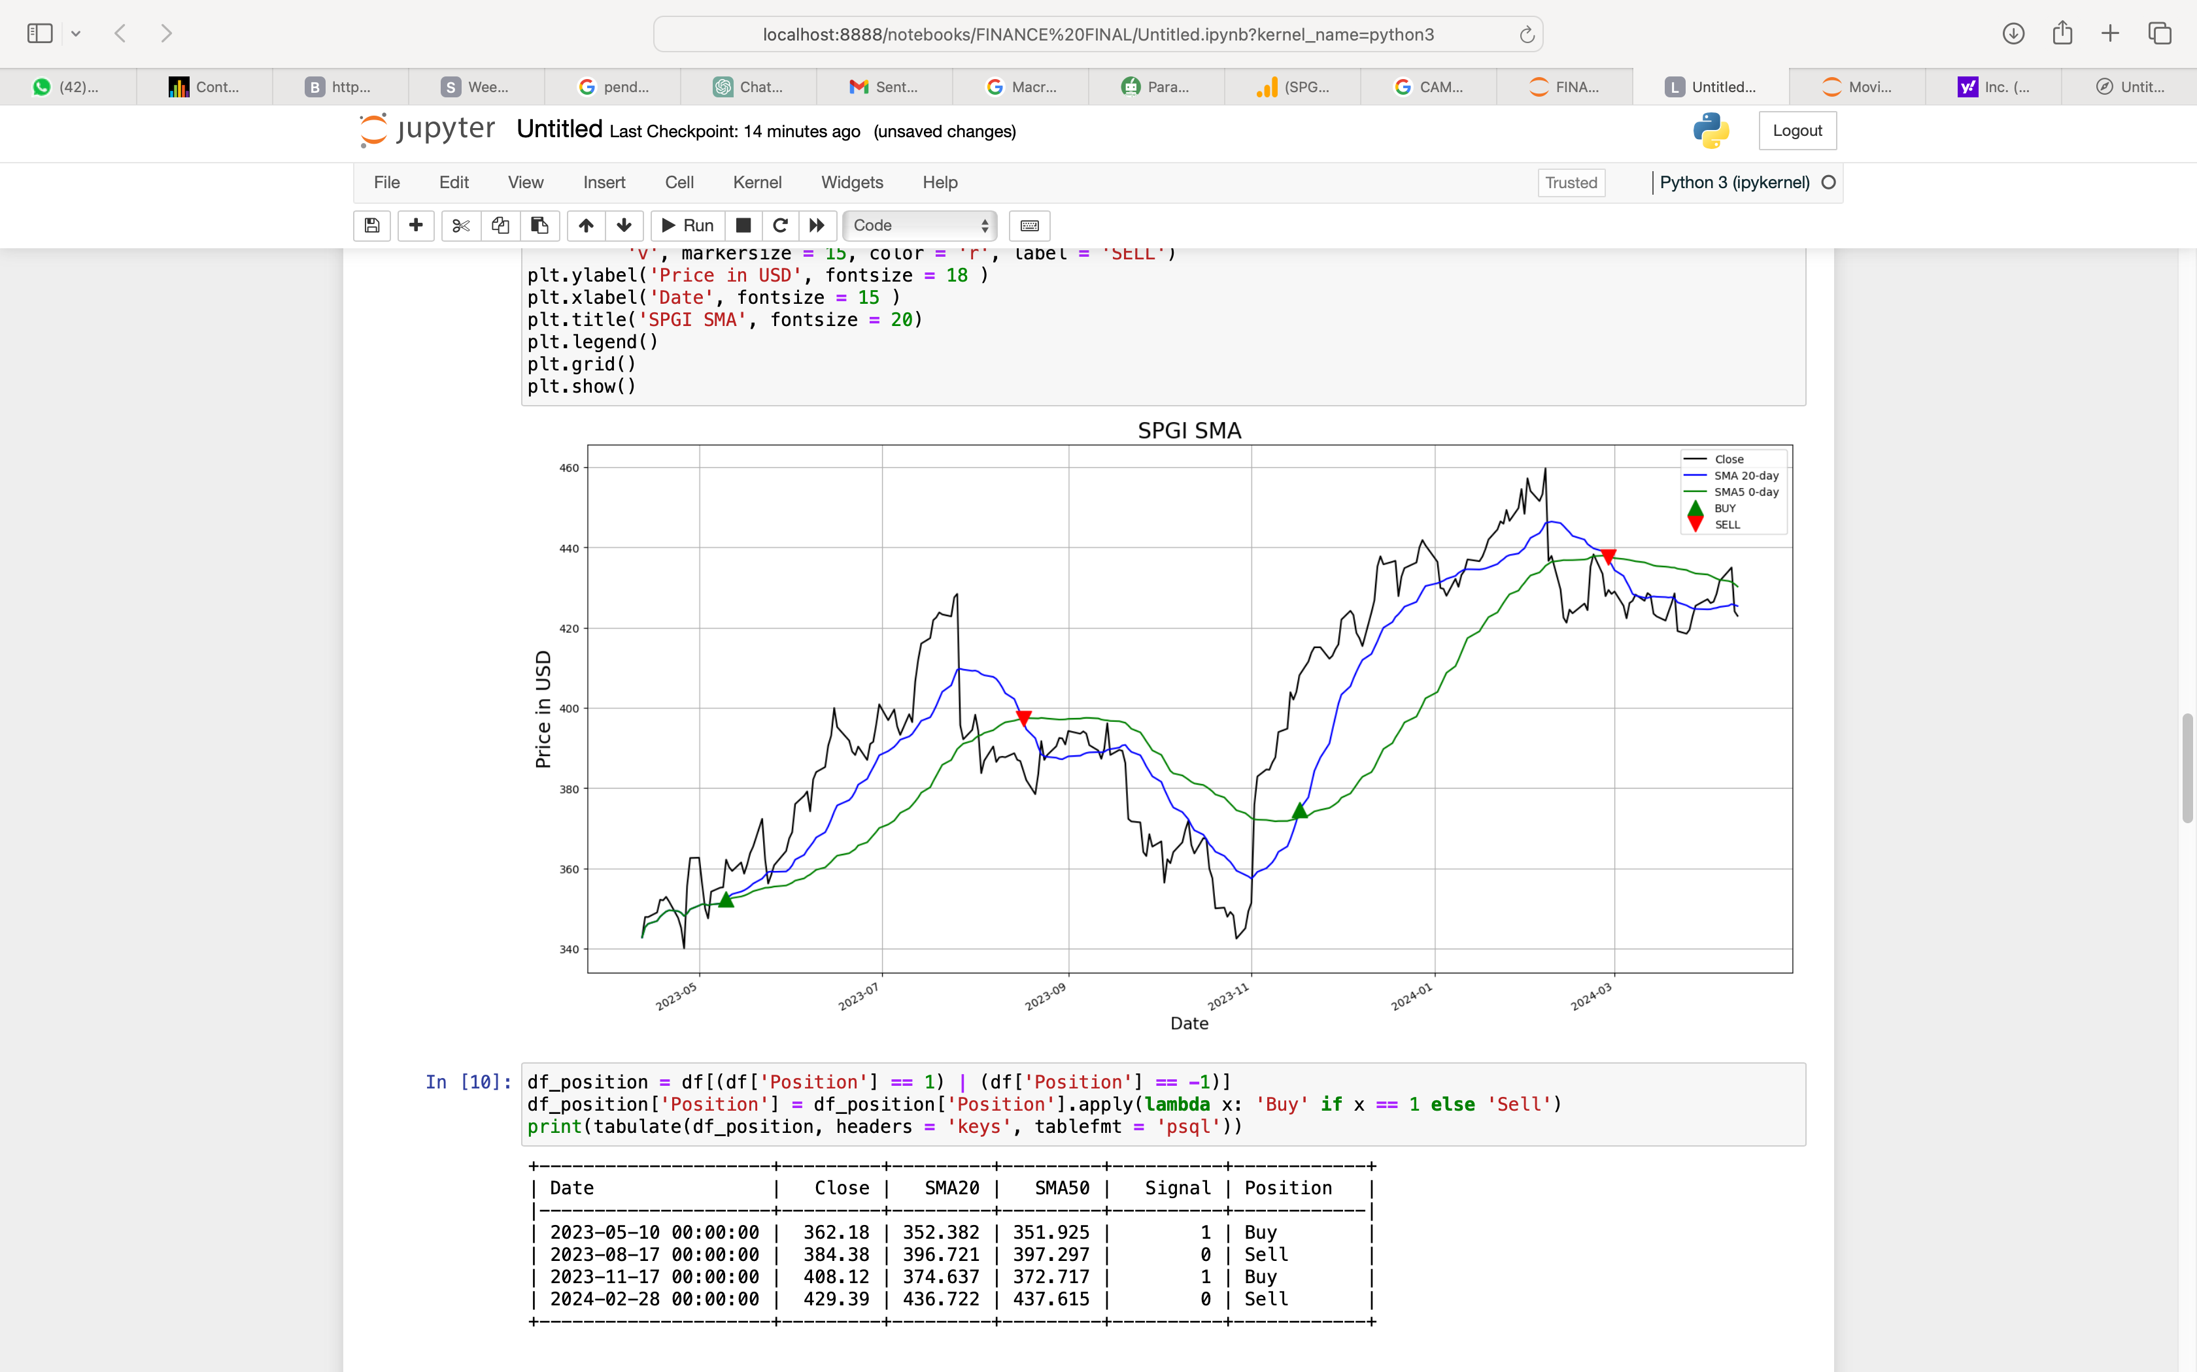

In finance, "Simple Moving Average" (SMA) is a popular technical analysis method. By generating a number of averages from various subsets of the entire data set, the technique is utilized to assess individual data points. SMA is most frequently used to analyze the price of securities, such stocks, bonds, and commodities.

Over here we can see when to buy and sell the stocks in the past . We get to know it as when SMA 20 goes down SMA 50 we need to sell it if SMA 20 goes up EMA 50 we need to buy more .

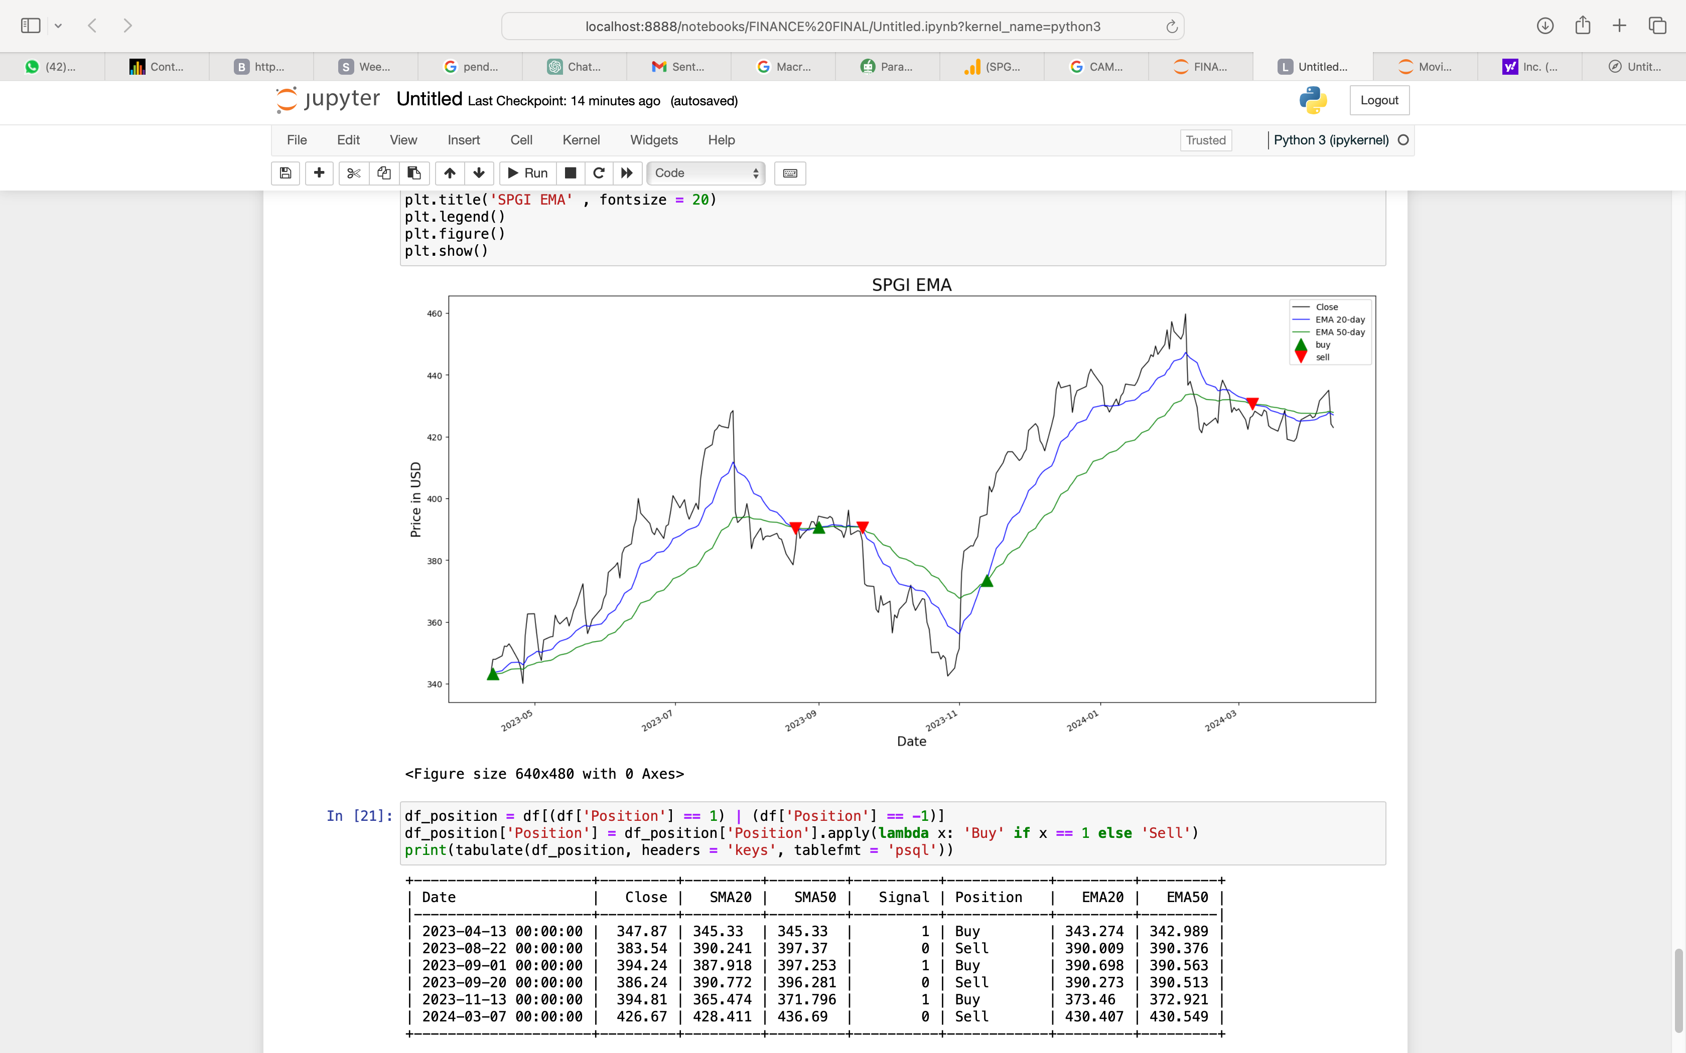

The acronym for Exponential Moving Average is "EMA". The Exponential Moving Average (EMA) is a technical analysis technique that is used to smooth and evaluate price data, much like the Simple Moving Average (SMA). EMA, on the other hand, uses a different calculating procedure than SMA, giving greater weight to recent data points. Because of this, EMA responds to recent price fluctuations more quickly than SMA, which weights each data point equally within the given time.

Over here we can see when to buy and sell the stocks in the past . We get to know it as when EMA 20 goes down EMA 50 we need to sell it if EMA 20 goes up EMA 50 we need to buy more .

**Monte Carlo Simulation**

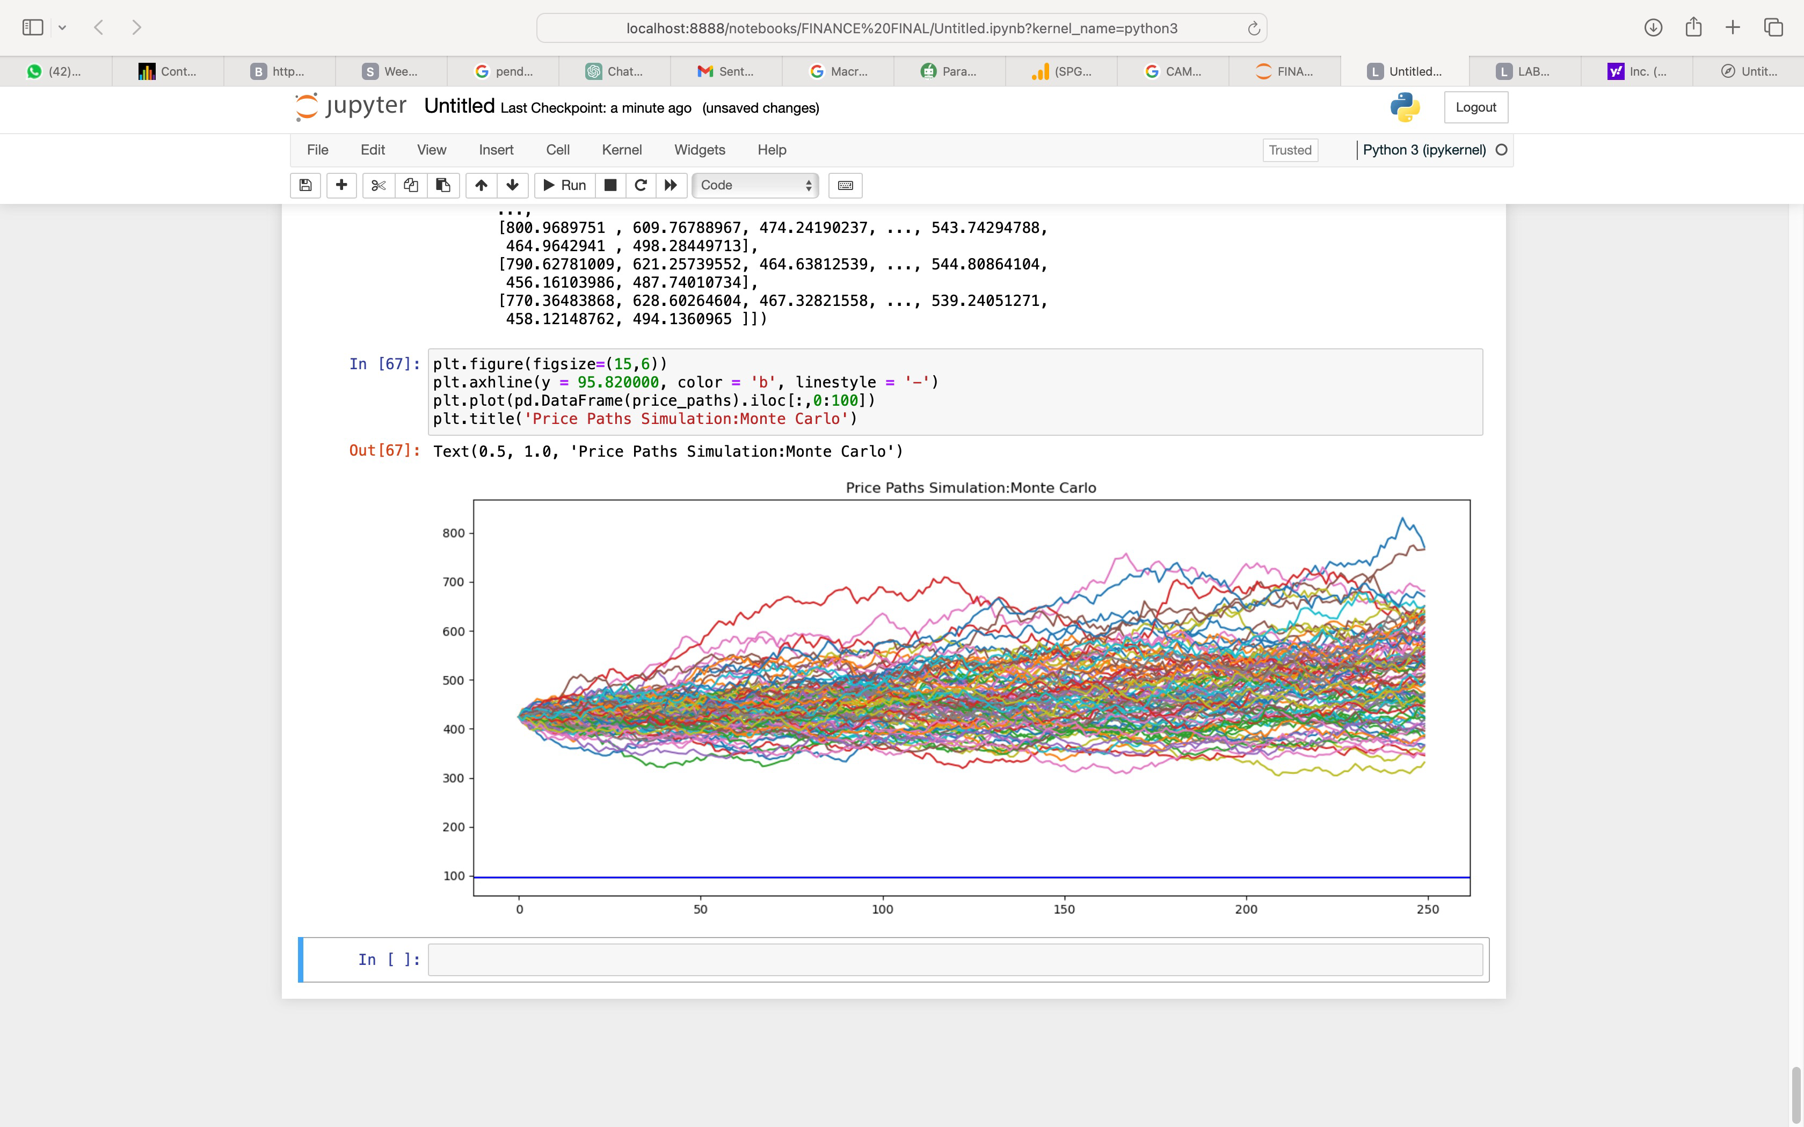

Probabilistic modeling helps decision-makers understand the range of potential outcomes and the likelihood of each outcome occurring. This insight enables them to make more informed choices by considering not only the most likely outcome but also the full spectrum of possibilities.

It's a Monte Carlo simulation, showing hundreds of possible future price movements for a stock.

Imagine each line as a "what-if" scenario considering factors like volatility. The cluster of lines shows the probability of the stock going up, down, or staying flat.

**Facebook Prophet**

An open-source time series forecasting library called Facebook Prophet is perfect for estimating market values. It analyzes historical data using an additive regression model that considers trends, seasonality (weekly, annual, and daily), and the impacts of holidays. Time series data with seasonal trends and a wealth of historical records work best with it.

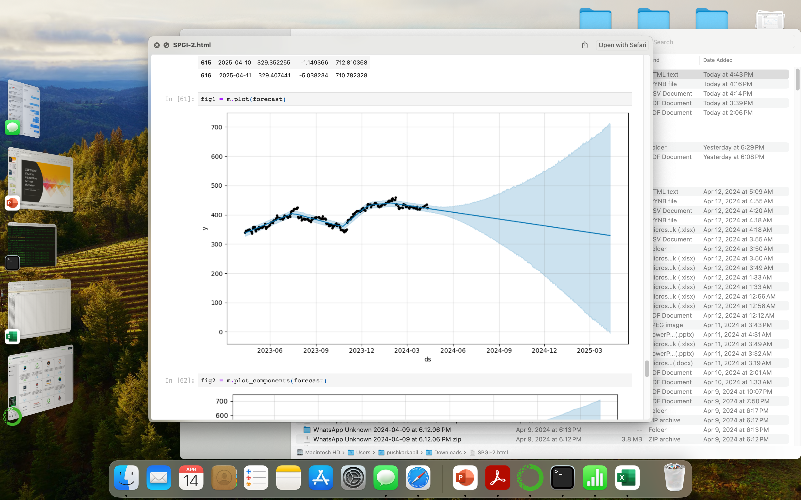

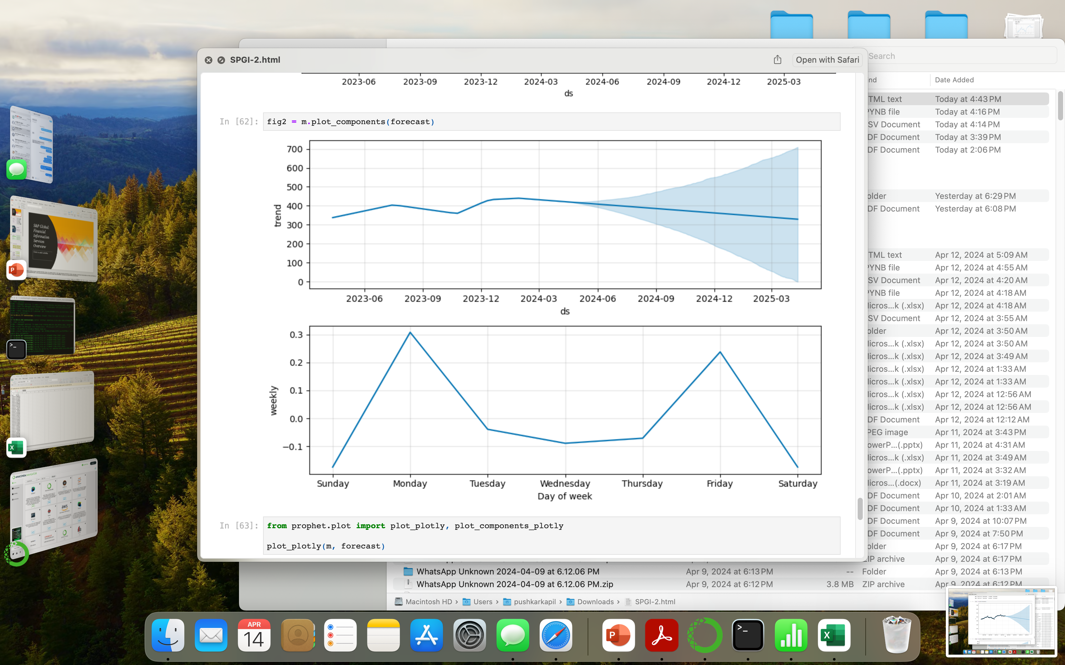

**Summary**

The goal of the research is to offer insightful information for investing decisions by evaluating SPGI's financial and market performance. The rise of SPGI from financial research to a global leader in financial information and analytics is outlined, beginning with a historical overview. Credit ratings, market intelligence, index creation, commodity information, risk management solutions, data analytics, ESG solutions, and market research are all examples of current activity. Strong operational efficiency and profitability are shown by ratio analysis, which also shows SPGI's liquidity, profitability, efficiency, leverage, and market value. The macroeconomic climate supports SPGI's plans for organic expansion, strategic alliances, and targeted acquisitions. While WACC, which represents the company's cost of capital, is computed at 8.15%, CAPM projects SPGI's asset return at 13.662%.

An examination of stock prices reveals notable variations, especially in November 2023, caused by changes in market mood. Moving average crossings provide historical buying and selling signals in SMA and EMA analysis. Taking volatility into account, Monte Carlo simulation offers insights into possible future price fluctuations. Finally, market value predicting using historical data is made easier by the Facebook Prophet library.

To sum up, the analysis provides a thorough assessment of SPGI's financial performance, market dynamics, and future prospects. It does this by utilizing a variety of analytical tools and methodologies to effectively inform investment decisions and help investors feel confident when navigating the complex financial markets.